Monday | Tuesday | Wednesday | Thursday | Friday
 |  |  |  | 2. Please don’t forget to vote for your GEM award.
5. Cheese Pizza Day. Let’s get cooking! | 6. Read a Book Day!  Today we will be reading and exploring different story books. |  |  | 9. Teddy Bear Day.  Bring your own teddy to nursery for our picnic at 3.30 - 4.15pm.
12. Grandparents Day.  Let’s create some lovely artwork for our grandparents. | 13. Chocolate Milkshake Day. Let’s make milkshakes. |  | 15. Make a Hat Day.  Today we will be creating our own hats. | 16. National Playdough Day. We will be creating different coloured play dough.
 | 20. Sibling Stay and Play. 4.15 - 5.00pm.  Bring your sibling to nursery and get involved in our activities. |  | 22. Homework for the month. Please see a staff member for this. | 23. Don’t forget your Home Observation’s.
26. Let’s go on a transport walk. | 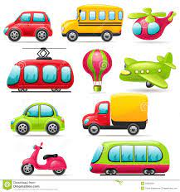 | 28. Let’s have a car wash. | 29. Let’s plant flowers.

