Monday | Tuesday | Wednesday | Thursday | Friday
3. Its World Vegetarian Day. We will be making a vegetarian dish. | 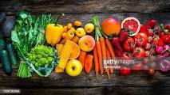 | 5. World Teacher Day.  Come dressed as a teacher today. |  | 7. We will be creating our own fruit salad for tea.
10. Please bring in your favourite book to share with your friends. | 11. We will be creating and exploring animals in ice cubes. |  | 13. Join us for our stay and play  4.15 - 5.00pm. We will be doing different crafting activities
17. Let’s go on a nature walk. | 18. Today we will be creating our own nature collage. |  |  | 21. We will be doing some vegetable printing.
24. Please come dressed in bright colours for Diwali. | 25. Homework of the month. | 26. Come dressed in Autumn colours. |  | 28. Don’t forget to vote for your GEM.
31. Come to Nursery dressed as a cat and pumpkin for our party.

