Monday | Tuesday | Wednesday | Thursday | Friday
 |  |  | 1. Let’s learn the sign for September. | 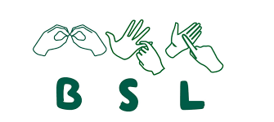
5. Transport Week. This week we will explore transport in different ways. | 6. We will be making our own vehicles using junk modelling and parts. |  | 8. Let’s go on the Birmingham tram today. | 9. Today let’s go for a walk.
 | 13. Roald Dahl Day. Please come to nursery dressed as your favourite character. | 14. Let’s make George’s Marvellous Medicine. | 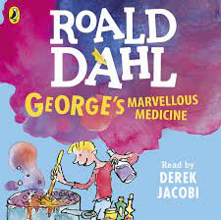 | 16. We will be making our own ears and tails like Fantastic Mr Fox.
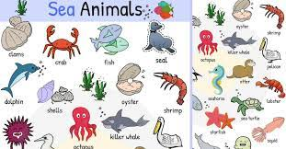 | 20. Today we will be painting pictures of sea creatures. | 21. We will be making a collage of sea creatures using different materials. | 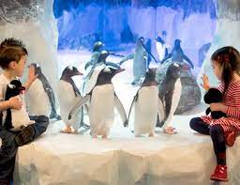 | 23. We will be visiting the Sea life Centre. Please see letter for more details.
26. European Day of Language. Let’s learn how to say hello in different languages. | 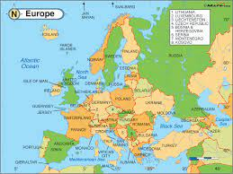 | 28. To celebrate Italy, we will be making our own healthy pizzas. | 29. Let’s learn some salsa. | 30. Wear red, white or blue to celebrate England.

