Monday | Tuesday | Wednesday | Thursday | Friday
 | 1. Don’t forget to vote for your Gem and bring in some Home Observations. |  | 3. Its Sandwich Day! Let’s create our own sandwiches. | 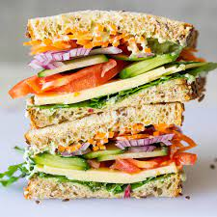
7. Book Lover Day.  Please bring in your favourite book to share. |  | 9. Let’s go on a leaf hunt in the garden. | 10. Let’s do some leaf printing. | 11. We will be making poppies to celebrate Remembrance Day.
14 World Kindness Day. Let’s create lovely pictures for our loved ones. | 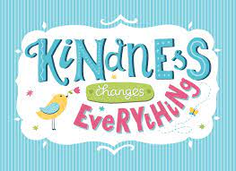 | 16. Homework of the Month. Please see Afshan for more details. |  | 18. Let’s create nature ice cubes.
21. Let’s create tree trunk pictures. | 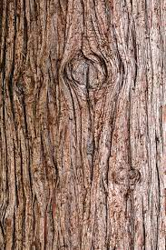 | 23. Today we will be doing some fruit printing. |  | 25. Thanksgiving. Let’s create Thanksgiving pictures.
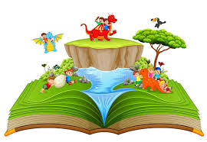 | 28. Stay and Play. Join us for stories and hot chocolate.  4.30 - 5.15pm. | 30. Let’s make banana muffins.

