Monday | Tuesday | Wednesday | Thursday | Friday
 |  |  | 1. Today we will be making hot chocolate.
5. Let’s create marks in the snow. |  | 7. Let’s make a Gingerbread Man. | 8. Today we will be decorating our Gingerbread Man.
12. Today we will be making handprint baubles. | 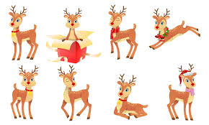 | 14. Today we will be making our own reindeer crafts. | 15. We will be making fruit pudding cake today.
19. Today we will be creating our own Winter collage using different materials. | 20. Let’s create snowflakes. | 21. We will be making our own Winter Wonderland tray. | 22. Let’s create our own snowman.
26. Nursery is closed due to the Bank Holiday. | 27. Nursery is closed today due to the Bank Holiday. | 28. Today we will be exploring coloured ice cubes. | 29. Today we will decorating biscuits.

