Monday | Tuesday | Wednesday | Thursday | Friday
 | 1. Today we will be designing crowns for our new King Charles. | 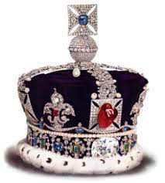 | 3. Today we will be creating fire pictures. | 4. Let’s create our own firework display.
7. Please bring in pictures from your own fireworks if you went to any displays. | 8. Today we will be learning sign language for some Autumn words. |  | 10. Today we will be making poppy biscuits. | 11. Please wear red and black to nursery today. We will be creating our own poppies.
14. Its Odd Sock Day in nursery. Come in your funniest pair of odd socks. | 15. Please bring in any old toys and clothes to create a Children in Need hamper. | 16. Today we will be taking part in a counting spots game for Children in Need. | 17. We will be creating Pudsey Bear masks. | 18. Please come to nursery dressed in yellow or in spotty colours for Children in Need.
21. Today we will be taking part in a traffic light game for road safety. | 22. We will be making traffic signs. We will be making an obstacle course of ‘stop and go’ in the garden. | 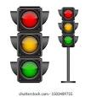 | 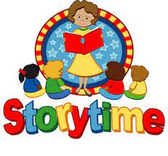 | 25. Please join us from 4.30 - 5.00pm for our Bedtime Story Stay and Play.
28. Today we will be decorating hats, gloves and scarfs. | 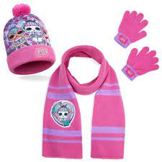 | 30. Today we are making our own hot chocolate to drink.

