Monday | Tuesday | Wednesday | Thursday | Friday
2. Bank Holiday. Nursery is closed today. | 3. New Year Party! Come dressed in party clothes. | 4. National Spaghetti Day. We will be exploring different coloured spaghetti. | 5. National Bird Day. Let’s paint our own birds. | 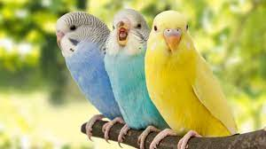
9. Bubble Bath Day. Let’s bath the babies with the bath bombs. | 10. National Chocolate Day. Let’s make chocolate treats for our parents. |  | 12. National Tea Day.  Come and join us at our stay and play!  3.30 - 4.15pm.
16. Don’t forget to vote for your GEM nominations. |  | 18. Winnie the Pooh Day. Come to nursery dressed as Winnie the Pooh. | 19. Pre-School will be looking after the babies today. | 20. Toddlers will be looking after the babies today.
23. Pie Day. Let’s create our own fruity pie. | 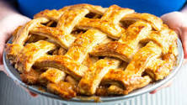 | 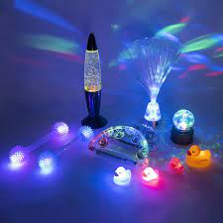 | 26. Today we will be creating our own sensory show using lights. | 27. Please complete any Home Observations and give them to your child’s Key Person.
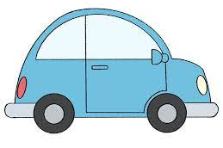 | 31. Car wash Day. Let’s wash our own cars and bikes.

