Monday | Tuesday | Wednesday | Thursday | Friday
 |  | 1. Storytelling Week.  Bring in your favourite book to share with your friends | 2. Please join us for our Stay and Play sessions. We will be reading stories together. 4.15-4.45pm
6. Please bring in your GEM award nomination. |  | 8. Let’s make a healthy snack to try at home. | 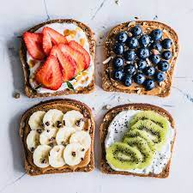 | 10. Today we will be making Valentines crafts to send home.
 | 14. Come to nursery dressed in red or pink. |  | 16. Let’s make a colourful fruit salad. | 17. Please bring in your Home Observations and Wow Moments.
 | 21. Pancake Day. We will be having a Stay and Play. Please join us from 4.30-5.00 to decorate pancakes. | 22. Please bring some pictures of you eating your pancakes at home. |  | 24. Let’s make icicles for the polar bears.
27. Polar Bear Day.
Come dressed as a polar bear.

