Monday | Tuesday | Wednesday | Thursday | Friday
 |  | 1. Please bring in your favourite book from home to read with your friends. | 2. Don’t forget to vote for your GEM award.
6. Transport Week! Let’s make traffic lights. | 7. Let’s decorate our traffic cones. | 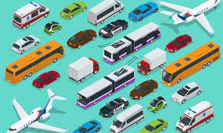 | 9. Competition time!  Make your own cars at home. The winner gets a prize! | 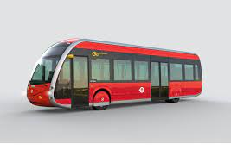
13. Let’s make cards for the people we love. | 14. Dress in pink or red for Valentine’s Day. |  | 16. Today we will be decorating bees for Be Kind Day. | 17. Kindness Day. We will be making friendships bracelets out of pasta.
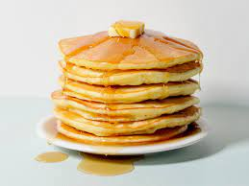 | 21. Pancake Day. Let’s make our own pancakes. | 22. Bring in pictures of your pancakes at home. | 23. Please bring in your Home Observations.
27. Polar Bear Day.  Wear white for Polar Bear Day | 