Monday | Tuesday | Wednesday | Thursday | Friday
3. National Autism Awareness Day  Come dressed in blue. |  | 5. Today we will be going on an Easter egg hunt around the garden. | 6. It’s our Easter bonnet competition!  Please bring in your bonnets that you have made at home. | 7. Good Friday. Nursery is closed today.
10. Easter Monday.  Nursery is closed today. | 11. Please bring in a picture of what you have done over the Easter break. | 12. Don’t forget your Gem award. |  | 14. Today we will be baking a cake. We will go to the local shop to collect what we need.
17. Today we will be giving out our monthly homework. Please speak to staff for information. |  | 19. See poster for details.  Please come to Nursery dressed in bright colours. | 20. Today we will be making EID cards and crafts. | 21. Happy Eid.  Please come to nursery dressed in red.
 | 25. Penguin Day.  Let’s create cold treats and explore ice. | 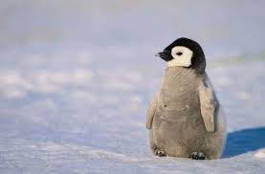 |  | 28. International Dance Day. Let’s learn how to dance in different ways.

