Monday | Tuesday | Wednesday | Thursday | Friday
3. Today we will be learning all about Easter. | 4. We will be going on an Easter egg hunt. | 5. Come to nursery dressed in pastel colours for Easter. | 6. Competition!  Bring in your Easter bonnets for our parade. | 7. Good Friday.  Nursery is closed today.
10. Bank Holiday Monday. Nursery is closed today. | 11. Its Pet Day.  Bring in pictures of your pets. |  | 13. We will be learning all about different animals that you have as pets today. | 14. Let’s create pet crafts or pictures of our pets.
 | 18. Please bring in any tinned/ cupboards food for Ramadan. We will give this to charity. | 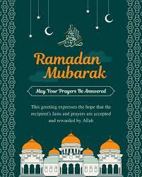 | 20. As part of your homework please can you make lanterns at home for Eid. | 21. Come to Nursery dressed in red and white for St Georges Day.
 | 25. Penguin Day.  Please dress in black and white for Penguin Day. | 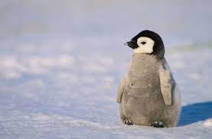 | 27. Please bring in your Home Observations. | 28. Don’t forget to vote for your GEM award.

