Monday | Tuesday | Wednesday | Thursday | Friday
 |  | 1. St David Day! Wear yellow for St David’s Day. | 2. Come to nursery dressed as your favourite character from a story for World Book Day.
6. Dinosaur Week. We will be learning all about dinosaurs. | 7. Come to Nursery dressed as dinosaur or dinosaur colours. | 8. We will be learning the dinosaur’s names and what they like to eat. | 9. We will be going on a dinosaur egg hunt | 10. We will be making salt dough dinosaurs.
13. Please bring a picture of yourself and your mummy. | 14. Come and join us for our Mother’s Day Afternoon tea and pamper.  From 3.30-4.30pm | 15. Today we will be making our own shamrocks. |  | 17. Please wear green for St Patricks Day or red for Red Nose Day.
 | 21. Bring in or make your favourite instruments to show your friends. | 22. Let’s learn about spring animals. | 23. We will be having a visit from Farm on Wheels. | 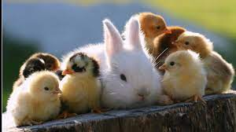
27. Please don’t forget to vote for your GEM of the Month. | 28. Come to nursery dressed in spring colours. | 29. Don’t forget your Home Observations. |  | 31. Wear your favourite hat.

