Monday | Tuesday | Wednesday | Thursday | Friday
 |  |  | 1. Disneyland Day. Come to nursery dressed as a Disney character.
5. Let’s do some flower printing. | 6. Today we will be creating a nature tray. | 7. Let’s make some yummy ice cream. |  | 9. We will be making marks with coloured ice cubes.
12. Let’s do some dinosaur printing. | 13. Let’s create summer collages. | 14. Mums to make Fathers day gifts with their babies for Fathers Day. Please join us 4.15-5.00pm. | 15. Please join us for our Father’s Day stay and play. Daddies, granddad or uncles.
19. Please bring in any empty bottles you may have at home. | 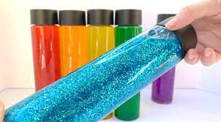 | 21. Let’s make sensory bottles. | 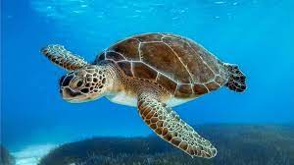 | 23. Its World Turtle Day. We will be exploring the turtles in the water.
26. We will be making Eid cards |  | 28. Eid Mubarak. Come dressed in your party clothes. |  | 30. Don’t forget to bring in your Home Observations.

