Monday | Tuesday | Wednesday | Thursday | Friday
 |  |  | 1. Its Dinosaur Day! We will be researching all about dinosaurs. | 2. We will be creating our own fact files about the dinosaurs.
5. For Environment Day we will be doing some litter picking. |  | 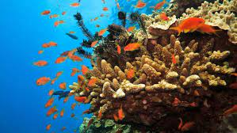 | 8. For World Ocean Day we will be looking at ocean animals. | 9. Don’t forget your Home Observations.
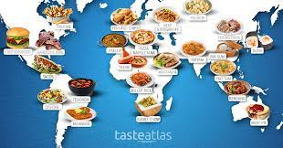 | 13. We will be testing different foods from around the world. | 14. Flag Day! We will be looking at the flags of the world and creating some of our own. |  | 16. We will be making treats for Father’s Day.
19. Tell us all about your Daddies, Grandads and what you love about them. | 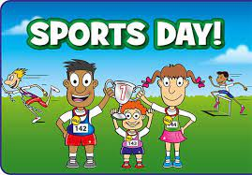 | 21. Please join us for some Sport’s Day fun in the garden 4.00-5.00 | 22. We will be learning all about healthy hearts following our Sport’s Day.  We will be making some smoothies! | 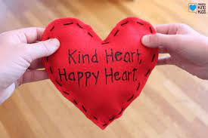
26. Today is the start of Children’s Art Week. | 27. We will be creating our own self-portraits. | 28. Today we will be looking at still life art work. | 29. We will be learning all about pointillism. | 30. Happy Birthday Mehwish!  Please wear blue today.

