Monday | Tuesday | Wednesday | Thursday | Friday
 |  |  | 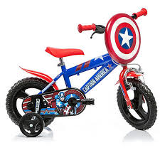 | 2. Let’s ride our bikes for World Bike Day.
5. Sausage Roll Day. Let’s create sausage / veggie rolls. | 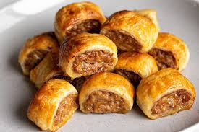 | 7. Let’s create fish picture collages. | 8. Ocean Day. Let’s create a sea world tray. | 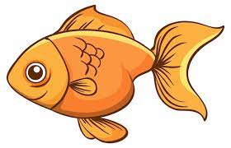
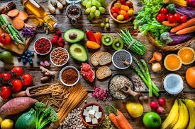 | 13. In aid of Healthy Eating Week let’s make food plates. | 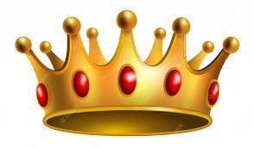 | 15. Let’s make cards for the Kings birthday. | 16. Let’s make our daddies some lovely treats.
19. Let’s learn about animals and habitats for World Giraffe Day. | 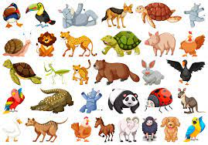 | 21. Music Day. Let’s sing and play instruments. | 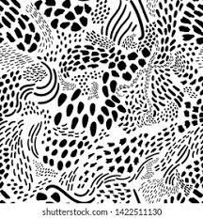 | 23. Let’s make marks in various ways for Writing Day.
26. Let’s make marks using cars. | 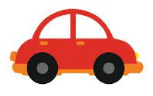 | 28. Happy Eid. Let’s create colourful collages. | 29. Let’s taste some Indian foods.

