Monday | Tuesday | Wednesday | Thursday | Friday
1. Bank Holiday.  Nursery is closed today. | 2. Please vote for Gem of the Month. | 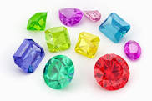 |  | 5. Space Day. Today we will be exploring shiny materials and making our own rockets.
8. Bank Holiday.  Nursery is closed today. | 9. Today we will be going on a nature hunt in the garden. | 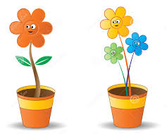 | 11. Today we will be creating our flower pots and decorating them. | 12. We will be creating our own flowers using different materials.
15. It’s Chocolate Chip Day. Today we will be creating our own chocolate chip cookies. | 16. Please come to nursery wearing purple for Peace Day. |  | 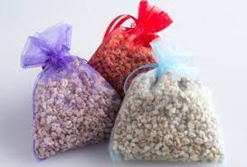 | 19. Today we will be creating scented bags.
22. Its National Strawberries Day. We will be going shopping to buy strawberries. | 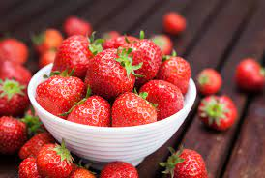 | 24. Today we will be making our own fruit salad. | 25. Let’s do some fruit printing.
29. Bank Holiday.  Nursery is closed today. | 30. Please bring back any Home Observations.

