Monday | Tuesday | Wednesday | Thursday | Friday
1. Bank Holiday.  Nursery is closed today. | 2. Today we will be making our own crowns. |  | 4. We will be going on a Gem Hunt in the garden. | 5. We will be making our own flags today.
8. Bank Holiday.  Nursery is closed today. |  | 10. Today we will be building castles. | 11. Today we will be dressing up like Kings and Queens. | 12. The toddlers will be designing their own shield.
15. Toddlers will be learning all about The Gruffalo this week. | 16. Today we will be writing our own Gruffalo story. | 17. It’s a Gruffalo hunt in the garden today for toddlers. | 18. Today we will be painting masks from the Gruffalo story. | 19. Please come to nursery dressed as a character from the Gruffalo.
22. Today we will be painting ice creams. | 23. Toddlers will be decorating summer hats today. | 24. Today we will be making our own flowers. | 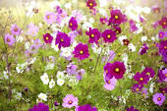 | 26. Please see poster for details.
29. Bank Holiday.  Nursery is closed today. | 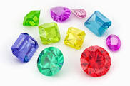 | 31. Don’t forget your GEM awards

