Monday | Tuesday | Wednesday | Thursday | Friday
3. Welcome to July! We will be exploring lots of activities outside today | 4. Independence Day. We will be making flags. | 5. World Chocolate Day.  Let’s make chocolate cupcakes. |  | 7. Please vote for your GEM award.
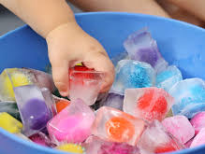 | 11. Today we will be creating using colourful ice and exploring the texture of this. | 12. Today we will be using different tools to chop up the ice to find the toy inside. | 13. Let’s make a summer collage using lots of different materials and resources. | 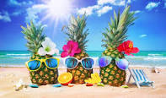
17. Today is our sports day. Please come to nursery in your sportswear. Parents are welcome to join us, see poster for details. |  | 19. We will be doing some ball painting using physical movement. | 20. It’s our Beach Day! Please bring your swim wear in. | 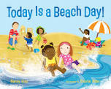
24. Today we will be making our own smoothies. | 25. We will be having a puppet show with Priyanka. | 