Monday | Tuesday | Wednesday | Thursday | Friday
3. Let’s learn all about the new month. | 4. Happy Birthday NHS! We will be doing some activities to learn all about the NHS. | 5. Show and Tell!  Please bring something from home to show your friends.  See poster for details. | 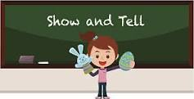 | 7. Today we will be making some decorations for our tea party next week.
10. We will be having a tea party today with our friends from the local care home. | 11. We will be writing a thank you letter for our friends at the local care home. |  | 13. Today the children will be focusing on their name writing and their pencil control. | 14. Its World Emoji Day! Let’s create some of our own to describe our feelings.
17. Staff meet and greet. Please come in and meet some of our new staff. More details to follow. |  | 19. It’s Sports Day! Please come dressed in your sportswear.  Sports Day will be 3.00-4.30pm. | 20. Its Nursery Beach Day! Please bring in your swim wear | 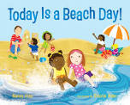
24. Today we will be having some old NHN students come in to talk about school life. | 25. International Friendship Week. | 26. Today we will be writing about what makes a good friend. |  | 28. Let’s create our own fruit salad.

