Monday | Tuesday | Wednesday | Thursday | Friday
 | 1. Welcome to a new month! What will we learn about this month? | 2. Today we will be creating a tuff tray all about animals that live in the sea. | 3. Please wear neutral colours today to celebrate one of our staff’s birthdays.
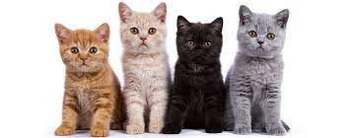 | 8. Please come to nursery dressed as a cat for our cat tea party.  3.30-4.15pm | 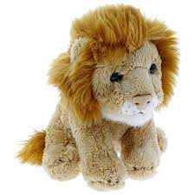 | 10. Let’s celebrate Lion Day by making a lion mask. | 11. Today we are going to have some fun with the soap foam.
14. Today we will be creating butterfly pictures. | 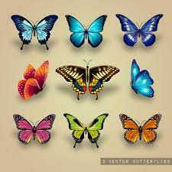 | 16. We will be making ice lollies today. Yummy! |  | 18. Please bring in any photos of what you have been doing over the weekend.
21. We will be creating bubble wrap paintings today. | 22. Please don’t forget to vote for your GEM. |  |  | 25. Please come to nursery wearing pink to celebrate one of the staff’s birthdays.
28. Bank Holiday.  Nursery is closed today. | 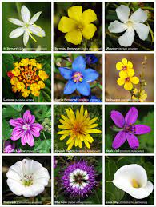 | 30. We will be doing some flower printing. Please bring in some flowers for us to use. | 31. Today we will be making flowers using different materials.

