Monday | Tuesday | Wednesday | Thursday | Friday
 | 1. It’s the first day of August. Let’s learn all about what happens in this month | 2. Let’s make some summer fruit punch today using some of our favourite fruits. |  | 4. Don’t forget Graduation Day tomorrow!
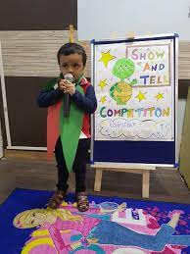 | 8. Please bring in something for Show and Tell. | 9. Today we will be writing recipe cards for what we need to make biscuits. | 10. Today we will be making shortbread biscuits. | 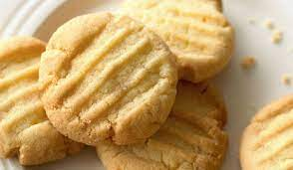
 | 15. Please join us for our bedtime story time. Come in your pjs! We will be sharing stories and having some warm milk. 6.00-6.45pm | 16. Today we will be talking about what ingredients we need to make pizza, make a list and then go and buy them. | 17. Let’s make our own pizza. What toppings shall we use?
21. Let’[s learn about the Gingerbread Man story. | 22. Today we will use role play to act out the story. | 23. We will be making our own story props. | 24. Let’s make Ginger Biscuits. | 25. Today we will be performing our story to the parents. Please come and join us!  4.00-4.30pm.
28. Bank Holiday Monday!  Nursery is closed today. | 29. Today we will be making friendship bracelets for Raksha Bandhan |  | 31. Today its party day in Preschool. Please come to nursery in your party clothes

