Monday | Tuesday | Wednesday | Thursday | Friday
 | 1. Welcome to a new month. Let’s learn about what happens in August. | 2. Today we will be looking at summer flowers and exploring the different colours. | 3. Today we will be using the flowers in paint to create our own pictures. | 4. Let’s make our own flowers from different resources.
7. Today we will be having a party for all our friends’ birthdays this month. Please come to nursery in your party clothes. |  | 9. Can you please bring in something for show and tell? | 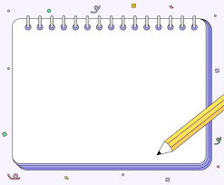 | 11. Please return any photos or home observations you have completed.
 | 16. We will be making our own pirate ships to see if they sink or float. |  | 17. Please dress up as a pirate to celebrate pirate month. | 18. We are going to be creating maps and finding treasure around the nursery.
21. 180 Katie- Startwell  Please come to nursery in your sportswear for our PE session. | 22. 2 - Snack Max  Today we will be baking healthy snacks. | 23. Sammy Skills Startwell  Today we will be learning balancing skills by taking part in an obstacle course. | 24. Fay 5 a Day.  We will be talking about our fruit and veg and exploring them in a tuff tray. | 25. Smiley Shein.  We will be talking about teeth cleaning and taking part in activities that will help to build our skills.
28. Bank Holiday.  Nursery is closed today | 29. Today we will be making our own binoculars ready for our bug hunt. | 30. Today we will be going on a bug hunt in the garden and seeing what we can find. | 31. Today we will be making our own bug hotels in the garden.

