Monday | Tuesday | Wednesday | Thursday | Friday
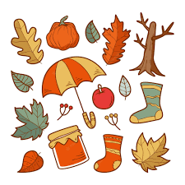 | 5. Autumn has arrived, Let’s create autumn collages. | 6. We will be making a autumn tuff tray. |  | 8. Today is Mariam’s last day!! Come dressed in your party clothes.
 | 12. Let’s create autumn themed sensory bottles. | 13. Today we will be doing some bubble wrap painting. |  | 15. Today we will be celebrating Jewish New Year.
18. Please bring in your home observations. |  | 20. Today is our Teddy’s Bears Picnic. Bring in your teddy. | 21. We will be having story time today. | 22. Let’s decorate biscuits using different coloured icing.
25. Let’s make yummy pizzas. |  | 27. Stay and Play Sensory Class. Come and join us between 2.30-3.30pm. | 28. Come to Nursery dressed in your favourite colour.

