Monday | Tuesday | Wednesday | Thursday | Friday
4. The start of Harvest Festival. Please see letter for more information. | 5. Today we will be creating healthy fruit smoothies. | 6. We will be creating vegetable smoothies. | 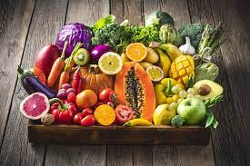 | 8. International Literacy Day. Please bring in your favourite stories.
11. Today is Preschool’s Teddy Bears Picnic.  Bring in your teddy bear. | 12. We will be creating our own healthy lunch boxes. | 13. Positive Thinking Day. We will be handing out some affirmation cards today. |  | 15. Let’s learn all about Rosh Hashanah, the Jewish New Year.
18. It’s the start of International Week of the Deaf. We will be learning sign language.  Today we will learn the days of the week. | 19. We will be learning the sign language for numbers. | 20. Today let’s learn how to sign our names. | 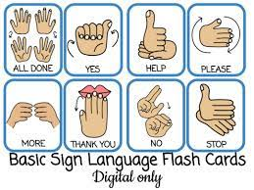  . | 22. We will be learning the sign language for colours.
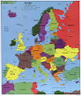 | 26. Europe Day of Language. Let’s learn how to say hello in the different languages. | 27. Today we will be trying different foods from around the world. |  | 29. Pre-school Tea and Breakfast Morning.  Please join us anytime from 7.00-8.30am.

