Monday | Tuesday | Wednesday | Thursday | Friday
 |  |  |  | 1. Let’s use tweezers to practise our fine motor skills.
 | 5. Cheese Pizza Day. Let’s make pizza. | 6. Let’s read our favourite books, for Read a Book Day. | 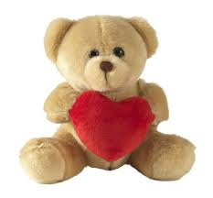 | 8. Let’s have a teddy bears picnic. Please bring in your own teddy from home.
11. Let’s make pretend milkshakes in the water tray. | 12. Milkshake Day. Let’s make fruit milkshakes. |  | 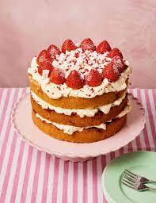 | 15. Let’s bake cakes today.
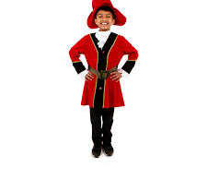 | 19. Let’s make a pirate tuff tray. | 20. Happy Birthday to two of our toddlers. Their birthdays are today and tomorrow | 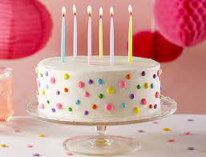 | 22. Let’s learn all about the planets.
25. Happy Birthday to one of our toddlers. | 26. Autumn has started.  Let’s do some leaf printing. | 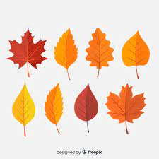 | 28. Let’s go on an Autumn hunt.

