Monday | Tuesday | Wednesday | Thursday | Friday
 | 4. Today we will be making sensory bags. |  | 6. Today we will be leaf printing with paint. | 7. Today we will be making our own sensory bottles.
10. Today we will be creating marks using conkers and different coloured paint. |  | 12. Today is farmer's day! Let's plant some vegetables. | 13. Today we will be going on an imaginative walk in the garden to visit the farm. | 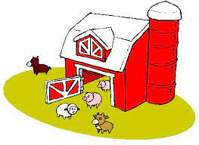
17. Today we will be making scarecrow crafts. | 18. Today we will be moving in different ways to get through the spider web. | 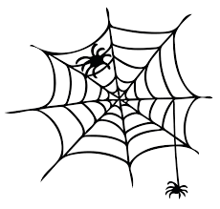 | 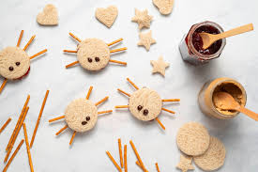 | 21. Today we will be making spider biscuits in cooking club.
24. Today we will be making spider crafts. | 25. Today we will be making spooky potions. |  | 27. Today we will be exploring coloured spaghetti and bugs. | 28. Come and join us for our Halloween themed Stay and Play. 4-5pm.
31. Nursery Halloween Party! Come to nursery dressed in fancy dress.

