Monday | Tuesday | Wednesday | Thursday | Friday
3. World Habitat Day.  Today we will be learning about different animal habitats. | 4. Come to nursery dressed as your favourite animal. | 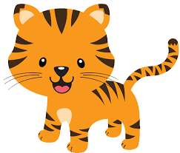 | 6. Today we will be exploring a safari themed tuff tray with different textures and prints. | 7. Today we will learn about season changes and look closely at what happens in Autumn.
10. Today we will be creating marks using conkers and different coloured paint. | 11. Today we will be going on an Autumn nature hunt in the garden. | 12. Forest School.  Let's toast marshmallows and create bonfire pictures. |  | 14. Today we will be making pumpkin soup in cooking club.
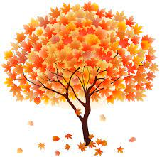 | 18. Let's explore the sizes of leaves on a hunt in the garden and put them into size order. | 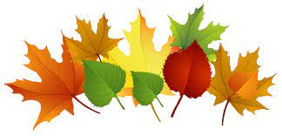 | 20. Today we will be making leaf wreaths. | 21. Today we will be using tweezers to save the bugs from Jelly.
24. Let's explore the inside of pumpkins and carve out shapes. | 25. Today we will be making pumpkin pictures. | 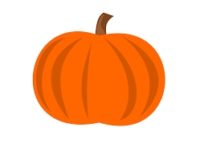 | 27. Today we will be making spooky potions in water. | 28.  Witches picture.
31. Nursery Halloween Party! Come to nursery dressed in fancy dress.

