Monday | Tuesday | Wednesday | Thursday | Friday
3. Today we will be making pumpkin soup in cooking club. | 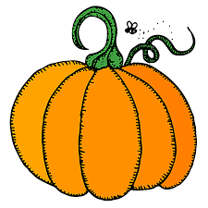 | 5. Today we will be making hedgehog crafts with leaves. |  | 7. Harvest assembly 4.30 – 5.00pm.
10. Today we will be making potions. |  |  | 13. Today we will be doing some leaf and tree painting. | 14. Today we will be making apple and cinnamon flapjacks in cooking club.
17. Let’s learn all about animals. | 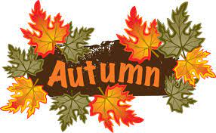 | 19. Autumn breakfast club. 7am-9am. | 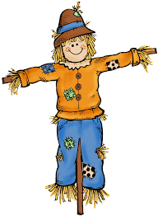 | 21. Today we will be making scarecrows using natural resources.
 | 25. Today we will be going on a sensory walk and exploring different textures. | 26. Pre-School Halloween Stay and Play. 4-5pm. | 27. Mark making day. Today we will be taking part in lots of mark making activities.
31. Nursery Halloween Party! Come to nursery dressed in fancy dress.

