Monday | Tuesday | Wednesday | Thursday | Friday
 |  | 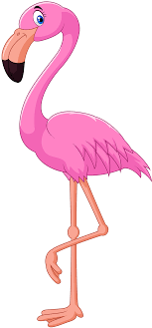 | 1. Today the children will be exploring the flamingos in pink custard. | 2. Today the children will be exploring the frogs in a five little frogs tuff tray.
5. Today we will be making our own cheese pizza. |  | 7. Today will be mark making using the paint pens. | 8. Today the children will be making mint tea in the water. | 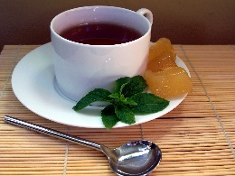
12. Today we will be mark making outdoors using the large chalks. | 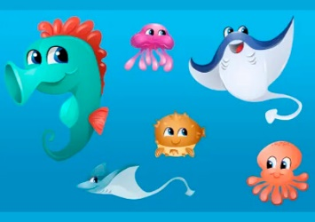 | 14. Today the children will be exploring sea creatures in blue gelllibaff. | 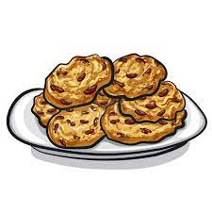 | 16. Today we will be making raison oats biscuits.
19. Today we will be going on a pirate adventure in the garden. | 20. Today we will be using tea bags to make our pirate maps. | 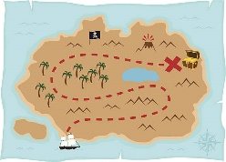 | 22. Today we will be making our own pirate telescopes. | 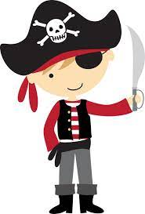
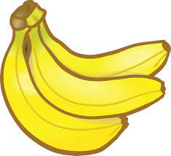 | 27. Today we will be making our own banana milkshakes. | 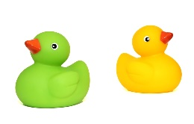 | 29. Today we will be exploring colours using the coloured rubber ducks.

