Monday | Tuesday | Wednesday | Thursday | Friday
 |  |  | 1. Today we will be making our own oat biscuits. | 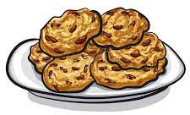
5. Today we will be practicing pencil grip and letter formation. | 6. National Read a Book Day! Today we will enjoy lots of story-based activities. |  | 8. Today we will be learning letter sounds in our names.
 | 13. Roald Dahl Story Day! Bring your favourite book to nursery. |  | 15. Come to nursery dressed as a  story character to celebrate World Book Day. | 16. Lets make chocolate cornflake cake.
19. Today is Talk Like a Pirate Day. We will be making lots of pirate crafts and roleplaying being pirates. | 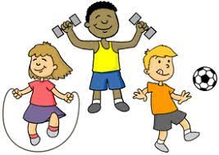 | 21. National Fitness Day! Let’s take part in lots of physical activities outdoors. | 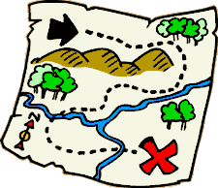 | 23. Today we will be going on a treasure hunt.
26. National Grandparents Day. Come and join us  4.30 - 5.30pm. | 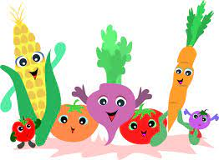 | 28. Harvest Day!  Please donate any fruit, vegetables and tins for toddler’s harvest basket. | 29. Let’s make fruit kebabs. | 