Monday | Tuesday | Wednesday | Thursday | Friday
 |  |  | 1. Today we will be making Reindeer masks.
5. Today we will be making our own salt dough ornaments. | 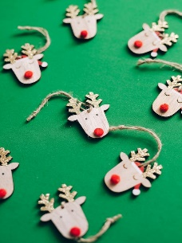 | 7. Come and join us for our Christmas stay and play. (See Poster) |  | 9. Today the children will be making their own candy canes.
 | 13. Today the children will be learning all about the Christmas Nativity. | 14. Today the children will be making springy snowmen. |  | 16. Come and watch our Christmas play!
19. Today we will be making Christmas biscuits. | . | 21. Today we will be having a visit from Father Christmas. | 22. We will be making reindeer food today to take home. | 23. Come to Nursery dressed in your Christmas pyjamas. We will be joining in with lots of fun activities and crafts.  We will also be having Christmas dinner.
26. Boxing Day!  Nursery will be closed today. | 27. Christmas Bank Holiday!  Nursery will be closed today. | 28. Today we be making our own New Year’s resolutions. |  | 30. Let’s discuss what we have enjoyed this year!

