Monday | Tuesday | Wednesday | Thursday |  | Friday
 |  |  | 1. Today we will be making our own Christmas wreaths
5. Today we will be making our own salt dough ornaments. |  | 7. Today the children will be making their own candy canes. | 8. Today we will be making snowman crafts. |  | 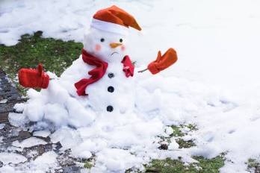
12. Today we will explore creating lava bottles with oil, washing up liquid, paint and glitter. | 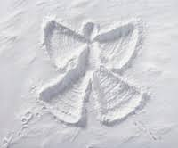 | 14. Let’s make snow angles in flour. | 15. Today we will be making Christmas biscuits. |  | 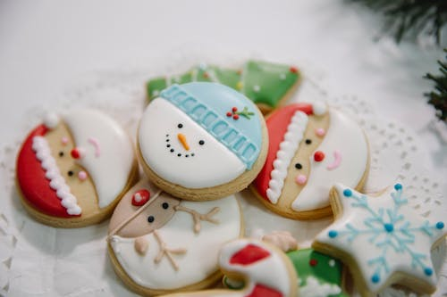
 | 20. We will be making reindeer food today to take home. | 21. Today we will be having a visit from Father Christmas. | 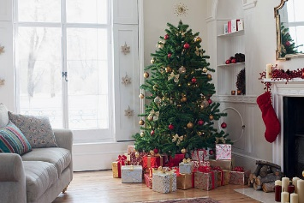 | 23. Come to Nursery dressed in your Christmas pyjamas. We will be joining in with lots of fun activities and crafts.  We will also be having Christmas dinner.
26. Boxing Day!  Nursery will be closed today. | 27. Christmas Bank Holiday!  Nursery will be closed today. | 28. Today we be making our own new year pictures. |  | 30. Bring in photos of family over the Christmas period to share with your friends

