Monday | Tuesday | Wednesday | Thursday | Friday
 |  |  | 1. Today we will be making our own season calendars.
5. Today we will be making our own melted snowman pictures. |  | 7. Today we will be making snowman biscuits. | 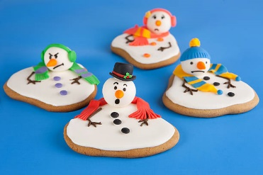 | 9. Today the children will be creating their own tree ornament.
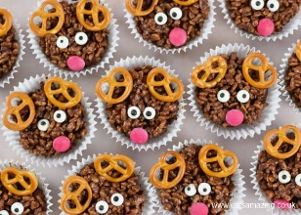 | 13. Today the children will be making reindeer cakes to take home. | 14. Today the children will be making there own drums. | 15. Today we will be creating our own Christmas tree crafts.
19. Today we will be exploring ice, exploring texture and learning new vocabulary such as cold, slipppy and wet. | 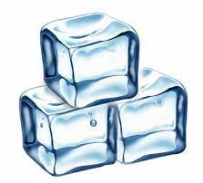 | 21. Today we will be making reindeer food to take home. | 22. Today we will be decorating our own baubles. | 23. Come to Nursery dressed in your Christmas pyjamas. We will be joining in with lots of fun activities and crafts.  We will also be having Christmas dinner.
26. Boxing Day!  Nursery will be closed today. | 27. Christmas Bank Holiday!  Nursery will be closed today. | 28. Today we will be snowball printing. |  | 30. Today we will be making firework pictures

