Monday | Tuesday | Wednesday | Thursday | Friday
 | 1. Let us explore a sensory tuff tray using washing up liquid, water, paint, glitter and wooden spoons. |  | 3. Today we will be using string and paint to make firework pictures. | 4. Let us explore our cooking skills and make Catherine Wheel cookies.
7. Let’s use sponges and colourful paint to create fireworks. | 8. Let us explore the Gruffalo book with bark, sticks, leaves and the Gruffalo teddy. | 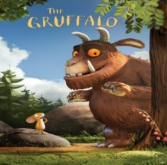 | 10. Today we will explore creating lava bottles with oil, washing up liquid, paint and glitter. | 11. Today we are going to make poppy’s for Remembrance Day.
14. Let us do hand painting to create spiders for the Incy Wincy spider for world nursery week. | 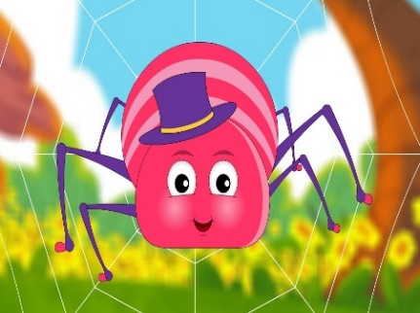 | 16. Let us explore a car tuff tray with roads and houses. | 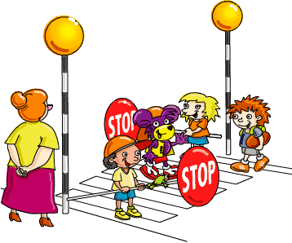 | 18. Let us explore a sensory tuft tray with different coloured materials.  We will create a Pudsey picture using paint balls for Children in Need.
21. Let’s make reindeer Rice Krispie cakes. | 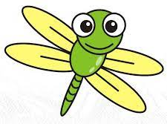 | 23. Today we will be exploring bugs in slime |  | 25. Today we will be exploring coloured rice (empty and filling)
28. Let us explore messy play with yellow and orange custard with cornflakes and bowls. | 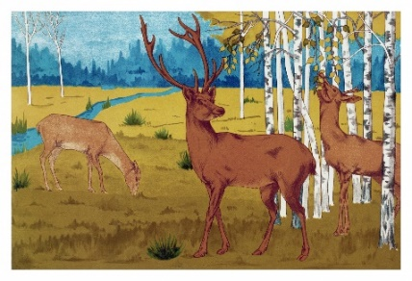 | 30. Let us explore leaf water play for National Tree Week.

