Monday | Tuesday | Wednesday | Thursday |  | Friday
 | 1. Today we will be splatter painting to make firework pictures. | 2. Today we will be making our own rockets. |  |  | 4. Today we will be roleplaying and having our own bonfire night outdoors.
7. Today we will be going on a bear hunt in the garden. | 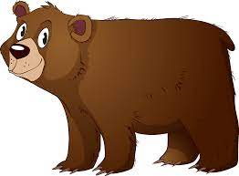 | 9. Today we will be doing a bare foot sensory walk. | 10. Today is Rememberance Day! We will be making our own poppy crafts.
 | 15. Today we will be using vegetables in paint to create marks. | 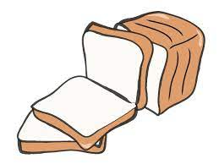 | 17. Today we will be making our own bread. |  | 18. Today we will be making our own shape pizza crafts.
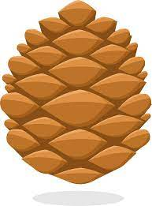 | 22. Today we will be using pinecones in paint to make our own pictures. | 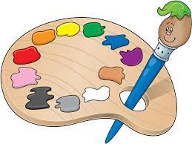 | 24. Today we will be making our own night lamps. |  | 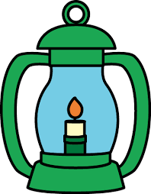
28. Today we will be making our own sensory bottles. | 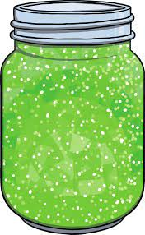 | 30. Today we will be mark making in boxes.

