Monday | Tuesday | Wednesday | Thursday | Friday
 | 1. Let’s create firework pictures. |  | 3. Today we will be making edible sparklers with breadsticks, sprinkles and melted chocolate. | 4. Diwali/bonfire and fireworks nursery party 5pm-7pm.
7. Today we will be making our own poppy biscuits in cooking club. |  | 9. Today we will be learning about Remembrance Day. |  | 11. Please come to our Remembrance stay and play 4:30-5:30.
14. Today we will be learning about road safety. |  |  | 17. Today we will be roleplaying in the home corner, pretending to be a chef. | 18. Today we will be baking flapjacks in cooking club.
21. Today we will be going on a nature scavenger hunt to find different natural textures outdoors. |  | 23. Today we will be making our own instruments out of junk modelling. |  | 25. Today we will be practising our cutting skills using scissors and playdough.
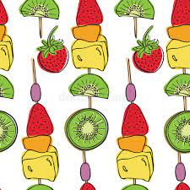 | 29. Today we will be making our own fruit kebabs in cooking club. | 30. We hope you have enjoyed our fun activities this month. Look out for December’s calendar for more exciting events.

