Monday | Tuesday | Wednesday | Thursday | Friday
 |  |  | 1. Today we will be decorating our room Christmas trees and putting up some decorations. | 2. Today we will create Christmas Tree crafts.
5. Today we will be learning about artic animals and creating our own. | 6. Today we are going to create winter pictures and talk about the weather changes in winter. |  | 8. Christmas Jumper Day!  Come to nursery wearing your best Christmas jumper. | 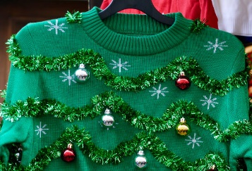
12. Today we will be size ordering different Christmas baubles. |  | 14. Ladybirds Room Christmas Stay & Play.  4:30-5:30. |  | 16. Today we are going to make Christmas shaped biscuits and decorate them with icing.
19. Grasshoppers Room Christmas Stay & Play.  4:30-5:30pm. | 20. Today we will be making reindeer food. | 21. National Robin Day.  Today we will be making our own Christmassy birds’ nests. | 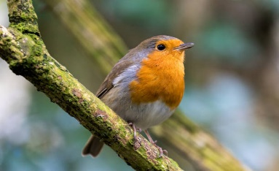 | 23. Come to Nursery dressed in your Christmas pyjamas to watch Christmas films and have Christmas dinner.
26. Boxing Day.  Today nursery is closed. | 27. Christmas Bank Holiday.  Today nursery is closed. | We hope you have had a lovely Christmas. We really enjoy hearing all about your celebrations. Please send any photos to your child’s key worker.

