Monday | Tuesday | Wednesday | Thursday | Friday
2. Bank Holiday.  Nursery is closed today. | 3. Today we will be making firework pictures.  (Spray bottle printing) |  | 5. Today we will be exploring a spaghetti bolognaise tuff tray. | 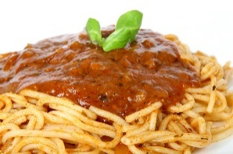
9. Today we will be making spring rolls. | 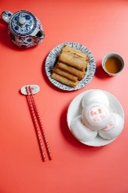 | 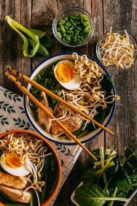 | 12. Today we will be making Chinese soup. | 13. Today we will be exploring a Chinese New Year tuff tray. We will be exploring a red and gold pasta themed tray.
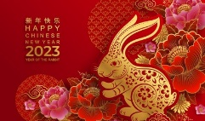 | 17. Today we will be making rabbit crafts. | 18. Today we will be making Winnie the Pooh masks to take home. | 19. Today we will be making spring rolls. | 20. Today we will be making lanterns for Chinese New Year!
23. Today we will be exploring coloured ice. |  | 25. Today we will be making healthy cupcakes. |  | 27. Today we will be making winter sensory bottles.
30. Today we will be making some fruit cupcakes. | 