Monday | Tuesday | Wednesday | Thursday | Friday
2. Today we will be making our own Hungry Caterpillar pictures. | 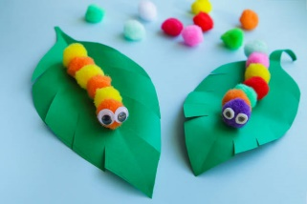 | 4. Today we will be using fruit to make Hungry Caterpillar kebab sticks. | 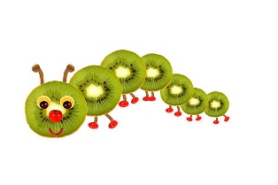 | 6. Today we will be exploring a Hungry Caterpillar tuff tray.
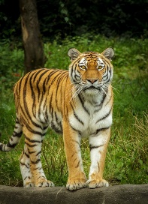 | 10. Today we will be using hammers to free the animals from ice. | 11. Today we will be exploring foamy water making potions. | 12. Today we will be making our own oat and raisin biscuits. | 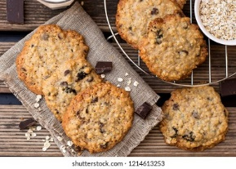
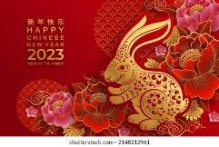 | 17. Today we will be looking at different Chinese words and using chopsticks to make marks in red/yellow sand. | 18. Today we will be food tasting! Let’s try lots of different Chinese foods. | 19. Today is International Flower Day! The children will be using flowers in paint to create their own pictures. | 20. Today we will be making lanterns for Chinese New Year.
23. Today the children will be making their own story puppets/sock puppets. | 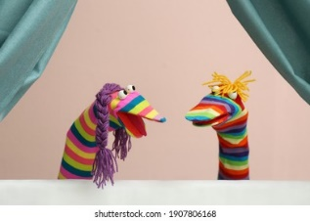 | 25. Today we will be having a story themed puppet show. | 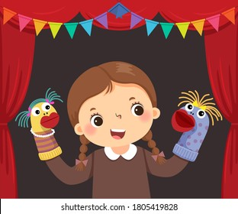 | 27. Today we will be exploring colours. The children will be learning colour names and organising coloured objects.
 | 31. Today we will be going on a colour hunt in the garden.

