Monday | Tuesday | Wednesday | Thursday | Friday
2. Bank Holiday. Nursery is closed today. |  | 4. Today we will be making firework pictures. |  | 6. Today we will be creating wishing wands.
9. Today we will be learning about different cultures and faiths. | 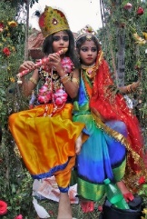 | 11. Come and join us for a pizza making stay and play. 4.30-5.30.
16. Today we will be going on a mini beast hunt. | 17. Today we will be learning about different inventions. | 18. Today we will be food tasting! Let’s try lots of different Chinese foods. | 19. Today we will be making lanterns for Chinese New Year. | 20. Come and join us for our Chinese New Year stay and play. 4.30-5.30
23. National Handwriting Day! We will be taking part in different mark making activities. | 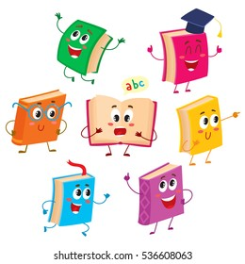 | 25. Library Day! Today we will be going to the school library. | 26. Today we will be making our own stories and retelling them to our friends. | 27. Today we are learning all about oral health and all about what dentists do.
 | 31. Today we will be exploring open ended resources and junk modelling our own models.

