Monday | Tuesday | Wednesday | Thursday | Friday
2. Bank Holiday Monday. Nursery is closed today. | 3. Today we will be making firework pictures. |  | 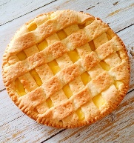 | 6. Today we will be making apple crumble.
 | 10. Today we will be making snowman biscuits. | 11. Today we will be making snowman pictures. | 12. Today we will be making vegan inspired sandwiches. | 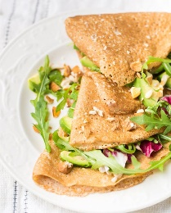
 | 17. Today we will be looking at different Chinese words and using chopsticks to make marks in red/yellow sand. | 18. Today we will be food tasting! Let’s try lots of different Chinese foods. | 19. Today we will be making lanterns for Chinese New Year! | 20. Penguin Awareness Day! Let’s dress up as penguins and make penguin crafts.
23. National Handwriting Day! We will be taking part in different mark making activities. |  | 25. Today we will be learning all about winter. |  | 27. Today we will be learning about Artic animals and creating fact files.
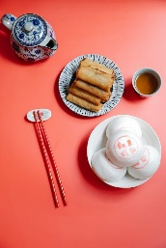 | 31. Today we will be making spring rolls.

