Monday | Tuesday | Wednesday | Thursday | Friday
 |  | 1. Today we will be making Valentine’s heart shaped footprints with salt dough. | 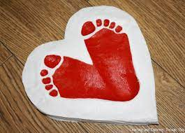 | 3. Today we will be exploring an Angel Delight tuff tray with cutters.
6. Let’s make some red oat cupcakes in a tray. |  | 8. Today we will be exploring some red foam with red objects. | 9. Today we will be making some heart shaped biscuits.
 | 14. Today we will be mark making using toilet roll tubes in the shape of a heart. | 15. Today we will be making Valentine’s cards for our mommy’s and daddy’s. |  | 17. Today we will be exploring red and pink spaghetti pasta with pots and pans.
20. Today we will be exploring red water in the water tray with rose petals and scoops. | 21. Today is Pancake Day. We will be making our own pancakes. | 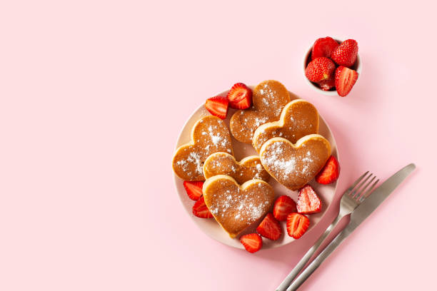 | 23. Today we will be dipping strawberries in melted chocolate. | 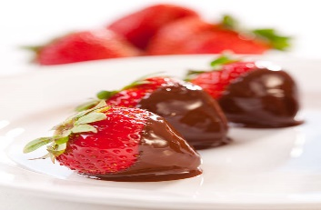
27. Today we will be making love potions in the water tray.

