Monday | Tuesday | Wednesday | Thursday | Friday
 |  | 1. Today we will be sensory ball painting. | 2. Come and join us for our story themed stay and play. 4:00 - 5:00pm.
6. Today we will be going on a jungle hunt in the garden. |  | 8. Today we will be exploring animals in foam. | 9. Today we will be making our own muffin pizza.
13. Today we will be making Valentine’s cards and crafts to send home to our loved ones. | 14. Come and join us for our Valentine’s Day stay and play.  4.30 - 5.30pm. |  | 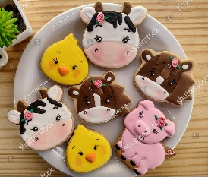  . | 17. Today we will be making our own farm animal biscuits.
20. Today we will be moving like different animals. | 21. Animal Puzzles! Today the children will be matching and sorting simple 2 piece puzzles to make the different animals. | 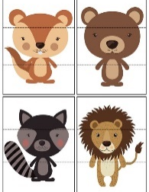 | 23. Today we will be using rackets and balloons in the garden to play tennis.
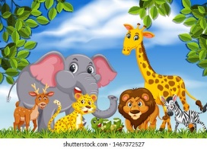 | 28. Today we will be using animals in paint to create marks.

