Monday | Tuesday | Wednesday | Thursday | Friday
 |  | 1. National Heart Month! Today we will be learning about the heart and what it does for our human body. |  | 3. NSPCC. Come and join us for our Number Day Stay and Play. 4.00 - 5.00pm.
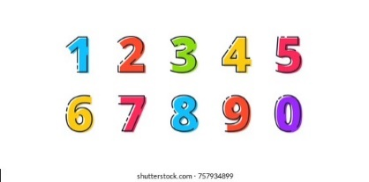 | 7. Today we will be looking at Esafety. |  | 9. Today we will be looking at road safety. | 10. Come and join us for our Phonics Stay and Play.  4.30 - 5.30pm.
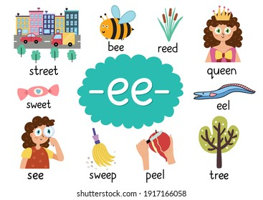 | 14. Today we will be making cards and crafts to send home to our loved ones. | 15. Crazy Hair Day! Let’s raise money for Sports Relief. | . | 17. Today we will be taking part in sports games for Sports Relief.
 | 21. Pancake Day! Today we will be taking part in lots of pancake activities. |  | 23. Today we will be learning about Lent and Ash Wednesday.
27. Today we will be making our own number lines.

