Monday | Tuesday | Wednesday | Thursday | Friday
 |  | 1. This week is National Story-telling Week. Today you can come to nursery dressed as your favourite story character. | 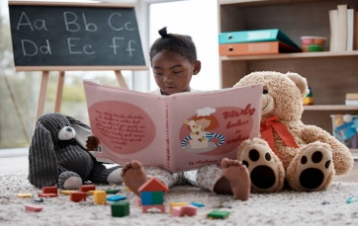 | 3. Today is NSPCC Number Day. We will be learning all about our numbers today.
 | 7. Today we will be exploring a red and pink sensory jelly tray. | 8. Today we will be using toilet roll to stamp hearts onto paper with paint. |  | 10. Today we will be making fruit kebabs.
13. Today we will be making Valentine’s cards. | 14. Happy Valentines Day! Today we will be creating heart crafts. |  | 16. Today we will be making jam tarts in cooking club.
 | 21. Today is Shrove Tuesday (Pankcake Day).  Today we will be making our own pancakes. | 22. Today we will be roleplaying with cooking tools and exploring a cooking tuff tray. |  | 24. Today we will be learning about animals and their habitats.
27. International Polar Bear Day! Today we will be making polar bear biscuits. |  | We hope you have enjoyed this month’s activities and events! Look out for next month’s calendar.

