Monday | Tuesday | Wednesday | Thursday | Friday
 | 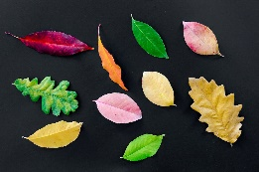 | 1. Today we will be doing leaf printing, exploring colours and the marks we can make. | 2. World Book Day!  Come to nursery dressed as your favourite book character. | 3. Today the children will be mark making with acorns in paint.
 | 7. Today the children will be mark making with fruit. | 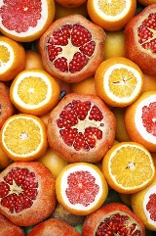 | 9. Today the children will be exploring lemons, limes and oranges in the water. | 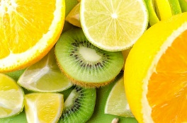
13. Today the children will be making their own cheesecakes. | 14. Today we will be making Mother’s Day cards. | 15. Today the children will be making Mother’s Day crafts. | 16. Today we will be making Red Nose Day cakes. | 17. Red Nose Day! Come to nursery dressed in red.
20. 1st day of summer!  Today we will be planting seeds. The children will bring these home to look after. | 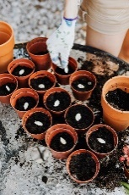 | 22. Today we will be creating our own flower crafts. | 23. Today we will be exploring flowers in the water, making potions. | 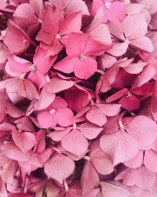
27. Today we will be having a Gruffalo puppet show. | 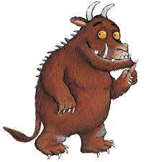 | 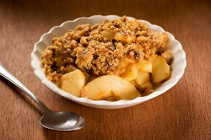 | 30. Today we will be making Gruffalo crumble. | 31. Today we be making Gruffalo hats.

