Monday | Tuesday | Wednesday | Thursday |  | Friday
 |  | 1. St David’s Day. Let’s make dragons. | 2. World Book Day. Dress up as book characters! |  | 3. Wildlife Day! Let’s create wildlife facts.
6. Let’s learn about Spring. | 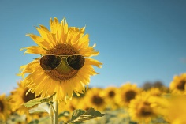  . | 8. Let’s do planting. | 9. World Kidney Day! Let’s learn about our kidneys. |  | 10. Who can make a pizza? Send your photos in to share with your friends.
13. British Science Week! Let’s do experiments. | 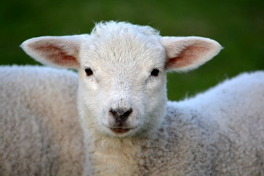 | 15. Let’s learn about animals in Spring. |  |  | 17. St Patrick’s Day. Let’s make lucky clovers.
20. Mother’s Day. | 21. World Oral Health Day! Let’s learn about cleaning our teeth. | 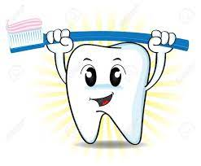 | 23. Let’s make bird feeders. |  | 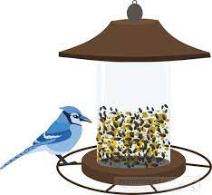
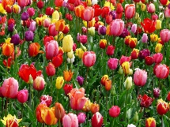 | 28. Let’s create Spring flower paintings. | 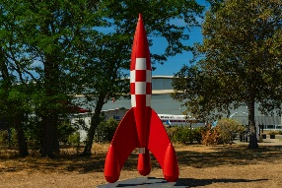 |  | 30. Let’s go on a space adventure. | 31. Let’s make name rockets.

