Monday | Tuesday | Wednesday | Thursday | Friday
 |  |  | 2. Today is World Book Day. Come to nursery dressed as your favourite book character and get involved with lots of story-based activities. | 3. Today we will be exploring a wildlife themed stuff tray and learning about different habitats.
6. Today we will be making flower sensory bottles | 7. Today we will be using vegetables to create flowers. | 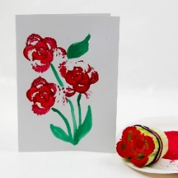 | 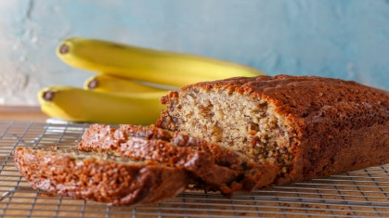 | 10. Today we will be baking banana loaf in cooking club.
 | 14. Today is International Maths Day. We will be exploring lots of numbers and shape activties today. | 15. Come and join us for a Mother’s Day Tea Party Stay & Play 4:30-5:30 in the garden. | 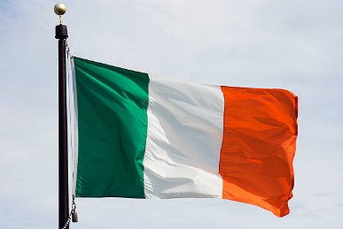 | 17. St. Patricks Day & Red Nose Day.  Today we will be making flags of Ireland and having a red themed day. Wear red clothes to nursery today.
20. Today we will be learning all about Spring and making crafts. | 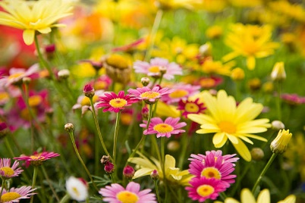  . | 22. Today we will be planting our own sunflowers and learning about the life cycle of a flower. | 23. Today we will be making heart shaped biscuits.
27. Today we will be learning about Ramadan. |  | 29. Today we will be making fruit salad for our families | 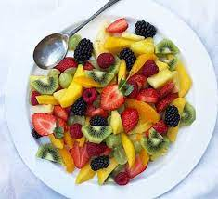 | 31. Today we will be making a healthy smoothie.

