Monday | Tuesday | Wednesday | Thursday | Friday
3. Today we will be mark making with Easter eggs in paint. | 4. Today we will be making Easter crafts. |  | 6. Today we will be catching Easter eggs in water using nets.  Today we will be making flags for St Georges day. | 7. Good Friday. Nursery is closed today
10. Easter Monday. Nursery is closed today. |  | 12. Today we will be exploring a flower / planting tuff tray. | 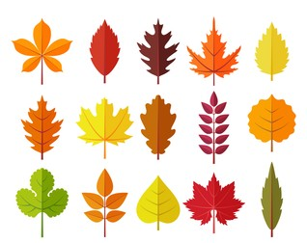 | 14. Today we will be mark making with natural resources from the garden.
 | 18. Today we will be exploring scented playdough. | 19. Today we will be exploring playdough with animals. | 20. Today we will be making flags for St Georges day.
24. Today we will be making chick crafts. |  | 26. Today we will be making spring potions outdoors. | 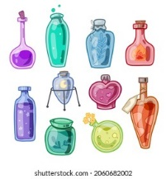 | 28. Today we will be using transport in playdough and explore the marks we can make.

