Monday | Tuesday | Wednesday | Thursday | Friday
3. Today we will be making Easter egg crafts. | 4. Today we will be making chick crafts. | 5. Today we will be making bunny crafts. |  | 7. Good Friday. Nursery is closed today.
10. Easter Monday. Nursery is closed today. | 11. Today we will be making sheep crafts.  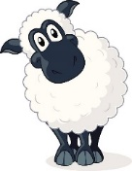 |  | 13. Today we will be exploring frozen foam.
17. Today we will be making pizza. | 18. Today we will be making Spring potions outdoors. | 19. Today we will be exploring colours using paint to mark make. |  | 21.  Today we will be making flags for St Georges Day.
 | 25. Today we will be mark making with transport. |  | 27. Today the children will be using bottles in paint to create flower pictures to send home. | 28. Today the children will be using flowers in paint to create their own pictures.

